**Serpentine Channel**

***Basic Component description***

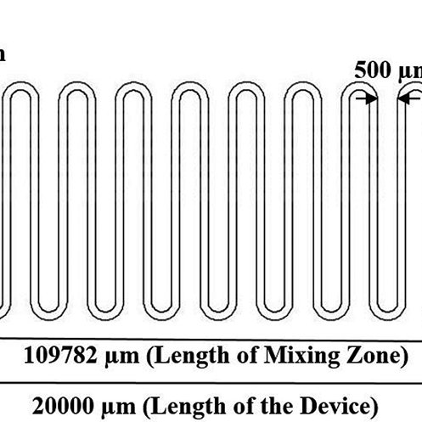

Channel that doubles back on itself, composed of alternating straight sections and curved sections.

***Component Specs***

Used for mixing (change in flow profile on curved sections) and increased resistance (or length) within confined device footprints

***List Input and Output nodes***

Figure 1: Example mixer diagram

mixer_example({P} [type] fluid input 1, (P) [type] fluid input 2, (V) [type] chemical 1 input, (V) [type] chemical 2 input, {P} [type] fluid output, {V} [type] Chemical 1 output, {V} [type] Chemical 2 output)

This section will describe the individual connecting nodes of the component. The descriptions show be brief and should not contain any equations but describe the how the “signal” is changed from input to output. As well as any other information about the interaction of the nodes. We will need to describe whither the nodes are physical channels or are virtual nodes that contain information on the fluid, such as viscosity, chemical concentrations. This will need to additionally contain what type of information will be carried by the node (It would be bad to connect a node that contains chemical concentration to a fluid flow node). This will be paired with a diagram like above to visualize how the nodes are connected.

***Microfluidic Operations***

Mixing, transport

***Component Verilog-AMS parameters***

Channel cross section (w | width, h | height) OR (r | radius)

Serpentine footprint (L | footprint length, W | footprint width, n | number of bends)

**ASSUMPTIONS:**

Straight channels flow along the footprint length (L)

Curved sections have an arc length of 180 deg

Channels and curved sections are evenly spaced out

The number of channels is equal to one more than the number of bends

***Virtuoso Description***

**OpenSCAD Description**

Information such as API and other important information that is useful for the user or an engineer trying to implement the module

***Manufacturing Description***

This section will contain information of the process that is need to create the component. This will include information on the exposure profile, and how this changes throughout the part, and special post processing steps that need to be done.

***Component model***

This will be the complete mathematical description of the geometric parameters with the flow properties, and any derivations needed.

Equations for resistance/flow rate are derived from straight channel component models, length is calculated as below.

***References***

[1] H. Bruus. “Chapter 1: Governing Equations in Microfluidics.” *Microscale Acoustofluidics*, 2014, pp. 1-28. <https://pubs.rsc.org/en/content/chapterhtm/2014/bk9781849736718-00001?isbn=978-1-84973-671-8>